Test Script

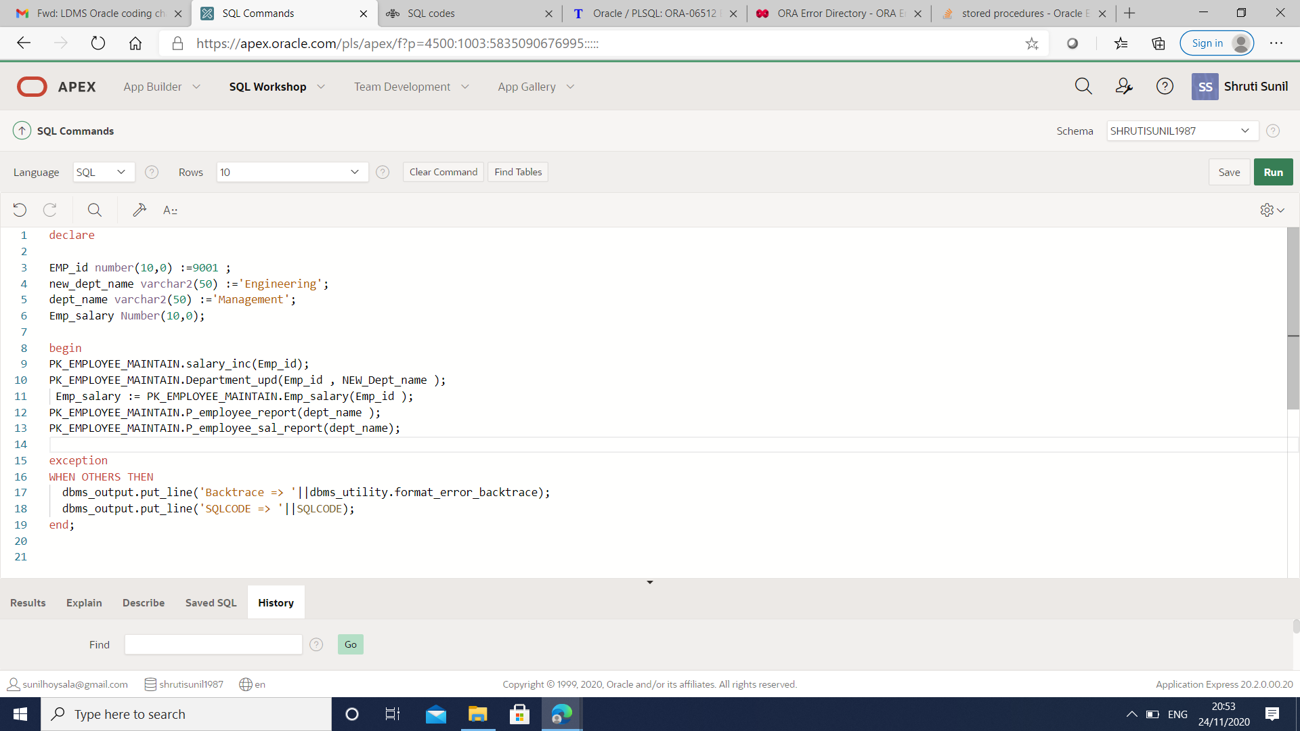

Output

I have used UTL_FILE package to write/generate report in unix box, since I don’t have the oracle directory on unix box, program could not write into the file

ORA-29280: invalid directory path

ORA-29280: invalid directory path

